UNISYS

City of Philadelphia 311

PhillyRising Marketing Campaigns Standards

**Copyright © 2014 Unisys Corporation**

**All rights reserved**

Version 1.0

Created 18 March 2014

**Revision History**

|  |  |  |  |
| --- | --- | --- | --- |
| Version | Date | Author | Summary of Changes |
| 1.0 | 3/18/14 | John Kelly | Initial draft. |
|  |  |  |  |
|  |  |  |  |

Contents

Overview 4

User Permissions 6

Defining Campaign Member Status 7

Creating a New Campaign 8

Campaign Edit Page Fields 9

Campaign Page Fields 12

Displaying a List of Campaigns 14

Displaying the Details of a Campaign 14

Editing an Existing Campaign 14

Adding Campaign Members to a Campaign 15

Editing Campaign Members 18

Updating the Status of Campaign Members 18

Removing Campaign Members 19

Creating Target Lists 19

Associating a Task to a Campaign 19

Creating a Copy of a Campaign 20

Printing Campaign Information 21

Sharing Campaigns 21

Deleting a Campaign 22

Gathering Information at Neighborhood Events 22

Importing Information from Neighborhood Events 23

Calculating Campaign Statistics 23

Campaign Reports 23

Results Reporting 24

Setting Up Campaign Hierarchies 25

Reviewing Campaign Hierarchies 26

Viewing Campaign Hierarchy Statistics 27

Configuring Campaign Hierarchies for PhillyRising 27

Configuring Campaign Fields 28

Configuring Related Lists 29

Configuring Assigned Apps 29

Configuring Campaign Picklists 30

Configuring Custom Fields 30

Configuring Permission Sets 30

Configuring Campaigns 30

Configuring Campaign Members 32

Configuring Campaign Page Layouts 33

Configuring Campaign Page Layouts 33

Configuring Campaign List Views 33

Configuring Campaign Goals 34

# Overview

The purpose of this document is to define how to create, update, and track marketing campaigns for PhillyRising using the Philly311 Salesforce solution.

The following table defines the basic campaign terminology.

|  |  |
| --- | --- |
| **App Name** | **Definition** |
| Campaign | A campaign is an outbound marketing project that you want to plan, manage, and track within Salesforce. It can be a direct mail program, seminar, print advertisement, email, or other type of marketing initiative. You can organize campaigns into hierarchies for easy analysis of related marketing tactics. |
| Campaign Member | Campaign members are created from lead, contact or person account records. Salesforce provides a variety of ways in which you can manage your campaign members. You can add and update up to 50,000 campaign members at a time through lead, contact, and person account reports; you can search for and add or edit multiple leads and contacts from the Manage Members page; you can add an unlimited number of leads and contacts using a CSV import file; or you can add members to a campaign one at a time from contact or lead detail pages |
| Campaign Manager | Campaign managers are users who have permissions to create, review, update, and delete campaigns. |

*Note: You cannot disable campaigns for your organization if campaigns are referenced in Apex.*

Managing campaigns in Salesforce involves the five major steps listed below.

1. **Create the Campaign**

After determining your campaign strategy, create a campaign to track your efforts.

1. **Create Your Target List**

Define who you want to target with your campaign. The method used to create a target list depends on who you are targeting:

* + **Rented or Purchased Lists** - Simply use the list of names as your target list. We recommend that you do not import the names into the system yet. *Note: Philly311 is not using this option at this time.*
  + **Existing Contacts, Leads, or Person Account** - Run a contact, lead, or person account report in Salesforce and use the **Add to Campaign** button to associate those records with your campaign. Alternatively, go to a list view of contacts or leads and use the **Add to Campaign** button to associate those records with your campaign. Note that person accounts are included in contact list views and can be added to campaigns from them.

1. **Execute the Campaign**

All campaign execution occurs outside of Salesforce. It can be online or offline, for example:

* + **Online** - Send email using an email execution vendor. *Note: Philly311 is not using this option at this time.*
  + **Offline** - Plan and host a conference; run print or radio advertisements; send direct mail pieces; or host a Web seminar.

1. **Track Responses**

The possible types of campaign responses can be divided into the following groups based on the response tracking mechanism:

* + **Website Response** - Prospects respond by filling in a form on your website. To track these types of responses, use a Web-to-Lead form to create a landing page for the campaign. Make sure to include the Campaign ID field when generating the HTML for the Web-to-Lead form. All responses are created as leads in Salesforce, and if the form includes the Campaign ID field value, the leads are directly associated to the campaign. To find your campaign ID, click on the campaign you have created. The last 15 digits in the URL represent the campaign ID. You can also include the Member Status field in the Web-to-Lead form. This field is “hidden” in the form (that is, it is not visible to campaign respondents), and it specifies the member status value to apply to all leads that respond via the web form. If you don't include this field in the web form, all new leads are assigned to the “default” member status specified in the campaign setup.

*Note: For Philly311, Salesforce Web-to-Lead functionality will be utilized to create a web form that will provide a mechanism to track a campaign member’s response and status.*

* + **Manual Update** - Customers and prospects respond via phone or mail, for example, a call to the sales team or a mail response card. To track these types of non-automated responses, a sales or marketing team member can manually update the Campaign History for the lead or contact in Salesforce.

*Note: For Philly311, if the campaign members respond via phone or other direct contact, agents will enter the customer’s information directly into the campaign through ordinary Salesforce channels. This will also be adapted to mobile use for PhillyRising representatives working directly with citizens in the field.*

* + **Mass Update** - If the person executing the campaign has sufficient privileges in Salesforce, he or she can use reports and list views to quickly update the statuses of multiple campaign participants at one time. To track these types of responses, a sales or marketing team member can run a custom contact or lead report and click Add to Campaign to select a new status for those campaign members. Alternatively, a sales or marketing team member can display a lead or contact list view, select the appropriate leads or contacts, and click Add to Campaign to select the new status for those campaign members.

*Note: For Philly311, mass updates will not be used at this time.*

* + **Offline Response** – Another type of response is any response that you track in an offline list, for example, trade show attendance or email responses from your email vendor. Import the offline list into Salesforce via the campaign Member Import option. Using the campaign import wizards, you can directly associate a lead or a contact with the campaign. Note: To use the campaign import wizards, users must have the Marketing User checkbox selected on the user detail page. They must also have the “Import Leads” permission.

*Note: For Philly311, if responses are being collected from citizens gathered at an event, the information will be imported directly from a spreadsheet or other electronic file into Salesforce using the Campaign Update Wizard*.

1. **Analyze Campaign Effectiveness**

The final step is to analyze the effectiveness of the campaign using reports and campaign statistics.

# User Permissions

Before you can create and manage campaigns, you must set up the appropriate user permissions.

Before setting up campaign management, you need to determine who should have access to campaigns. By default, all users have read access to campaigns, while only users with the Marketing User checkbox selected on their user record can create, edit, or delete campaigns. Consider the following information when determining campaign access:

* Marketing Users can view, create, edit, and delete campaigns as long as they have the “Read,” “Create,” “Edit,” and “Delete” permissions for campaigns.
* Marketing Users can run campaign reports and configure advanced campaign setup, which includes managing letterheads, HTML email templates, and public documents.
* Users with the Marketing User checkbox selected can mass manage campaign membership.
* To use the campaign import wizards, users must have the Marketing User checkbox selected on the user detail page. They must also have the “Import Leads” permission.
* Users that don't have the Marketing User checkbox selected only have access to view campaigns and advanced campaign setup, edit the Campaign History for a single lead or contact, and run campaign reports if they have the “Read” permission for campaigns.
* You can segment campaign visibility between organizational units by customizing the campaign sharing model. For instance, if you only want non-marketing users to view campaigns in their region, campaign sharing can be used to meet this need.

The following table describes the user permissions that are required for campaigns.

| **TO Do This…** | **YOU Must Have This…** |
| --- | --- |
| Create a campaign | “Create” permission for campaigns AND Marketing User checkbox selected on your personal information page. |
| Create a campaign hierarchy | “Create” on campaigns AND Marketing User enabled in your user detail page |
| View a campaign or campaign hierarchy | “Read” permission for campaigns. |
| View a campaign hierarchy | “Read” permission for campaigns. |
| View the campaign members related list | “Read” permission for campaigns. |
| Share a campaign | “Read” permission for campaigns AND Marketing User checkbox selected on your personal information page. |
| Edit a campaign | “Edit” permission for campaigns AND Marketing User checkbox selected on your personal information page. |
| Edit a campaign hierarchy | “Edit” permission for campaigns AND Marketing User checkbox selected on your personal information page. |
| View and use the Manage Members button on the campaign members related list | “Edit” on campaigns AND “Read” on leads or contacts |
| Edit the campaign members related list | “Read” on campaigns AND “Read” on leads or contacts |
| Delete a campaign | “Edit” permission for campaigns AND Marketing User checkbox selected on your personal information page. |
| Use the lead import wizard | “Edit” on campaigns AND Marketing User checked in your user information AND “Import Leads”. |
| Use the campaign update wizard | “Edit” on campaigns AND Marketing User checked in your user information AND “Import Leads” AND “Read” on contacts. |
| Customize member status values | “Edit” permission for campaigns AND Marketing User checkbox selected on your personal information page. |
| View Advanced Campaign Setup | No permissions required. |
| Edit Advanced Campaign Setup | “Edit” permission for campaigns AND Marketing User checkbox selected on your personal information page AND at least read/write sharing access on the campaign record. |
| Run a campaign report | ????? |

Also, at a minimum, marketing team members should have read access to all leads, contacts, and opportunities that could be associated with campaigns.

# Defining Campaign Member Status

For each campaign, Marketing Users must define campaign Member Status values. These are the statuses that a lead, contact, or person account may have for a campaign. For example, you might define values of “Planned,” “Sent Invitation,” “RSVP,” and “Attended” for a conference.

If you want to copy the Member Status values from an existing campaign, you can begin by cloning that campaign.

If you replace member status values, all campaign records are updated regardless of your sharing access to the related contacts or leads.

New campaigns have two default member status values: “Sent” and “Responded”. You can edit them or create new ones.

1. Click Advanced Setup on a campaign detail page.
2. Click Edit.
3. Update the existing entries or add new values.
4. Click Add More as needed to add additional entries. You can add up to 50 entries.
5. Select one entry as the “Default” value.
6. Choose which values will be counted as “Responded.” Members with “Responded” values are tallied in the Total Responses field on the campaign. Note

Modifying the Responded checkbox has broad effects. When you select or deselect the Responded checkbox, campaign statistics and campaign member details change accordingly. Specifically, the fields Responded, Last Responded Date, and Last Modified change on the campaign member record. For example, if you're working with a status called “Attended” and you select the Responded checkbox for it, existing campaign members whose status is “Attended” will then be counted as responses in campaign statistics and the aforementioned date fields will update.

You can globally replace the Member Status values for each campaign member. For example, you may decide that “Attended” is a more appropriate value than “Showed Up.”

1. Click Advanced Setup on a campaign detail page.
2. Click Replace in the Member Status Values related list.
3. Enter the value you want to change, and select the new value.
4. Click Save.

*Note: Replacing the campaign member status doesn't recalculate roll-up summary fields or fire workflow, triggers, or validation rules.*

# Creating a New Campaign

The City will use the following “standard” high-level steps to create a marketing campaign:

1. In the App Menu, choose the Marketing app.

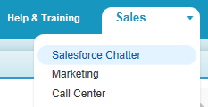

1. Click the Create New button.

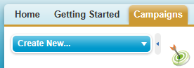

1. Choose the Campaign option

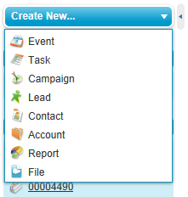.

Result: Salesforce displays the Campaign Edit page that you can use to create the campaign.

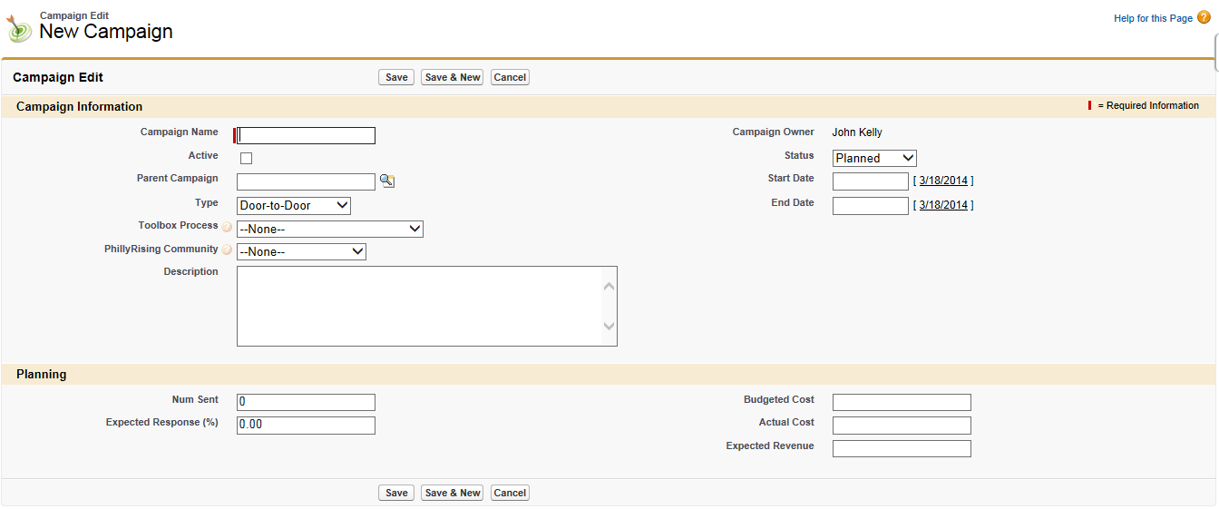

1. Enter the appropriate information in the New Campaign fields. This information is used to track the progess of the campaign and report on the success of the campaign.

# Campaign Edit Page Fields

Salesforce displays the following fields on the Campaign Edit page:

| **Section** | **Field** | **Description** | **Comment** |
| --- | --- | --- | --- |
| Campaign Information | Campaign Name | Identifying name for the campaign. | Required field |
|  | Active | Checkbox to mark whether the campaign is active or not. |  |
|  | Parent Campaign | The campaign above the selected campaign in the campaign hierarchy. |  |
|  | Type | Type of campaign, for example, Direct Mail or Referral Program.  Door-to-Door, Door Hangers, Mass Email, Mass Advertising, Targeted Email, Website | Entry is selected from a picklist of available values, which are set by an administrator. Each picklist value can have up to 40 characters. |
|  | Toolbox Process | The specific activity to be used for this campaign.  Citizen Engagement Academy, Large-Scale Volunteer Event, MAP Mural, Alleyway Cleaning Campaign, Domestic Violence Workshop, Neighborhood Liaison Training, Career Boot Camp, Computer Lab, Quality of Life Survey, Community Leader Social, Gardening Project, Health Fair / Outreach, Dream Drive. | This is a custom field created for PhillyRisiing. |
|  | PhillyRising Community | The PhillyRising community targeted for this campaign.  Elmwood, Frankford, Haddington, Hartranft, Kensington, Kingsessing, Lawncrest, Market East, North Central, Penrose, Pt. Breeze, St. Hugh, Southeast, Strawberry Mansion, Swampoodle | This is a custom field created for PhillyRisiing. |
|  | Description | Description of the campaign. | Up to 32KB of data are allowed in this field. Only the first 255 characters display in reports. |
|  | Campaign Owner | Assigned owner of the campaign. | Automatically populated |
|  | Status | Status of the campaign.  Planned, In Progress, Completed, Aborted, None | Entry is selected from a picklist of available values, which are set by an administrator. Each picklist value can have up to 40 characters. |
|  | Start Date | Starting date for the campaign. |  |
|  | End Date | Ending date for the campaign. Responses received after this date are still counted. |  |
| Planning | Num Sent | Number of individuals targeted by the campaign. For example, the number of emails sent. |  |
|  | Expected Response (%) | Percentage of responses you expect to receive for the campaign. |  |
|  | Budgeted Cost | Amount of money budgeted for the campaign. |  |
|  | Actual Cost | Amount of money spent to run the campaign. |  |
|  | Expected Revenue | Amount of money you expect to generate from the campaign. |  |

1. Click the Save button. Salesforce saves the campaign information and displays the Campaign page.

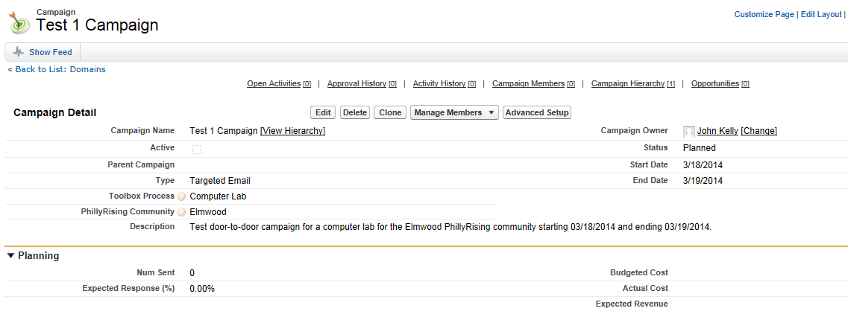

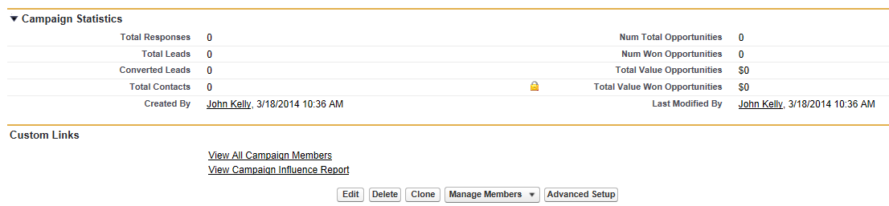

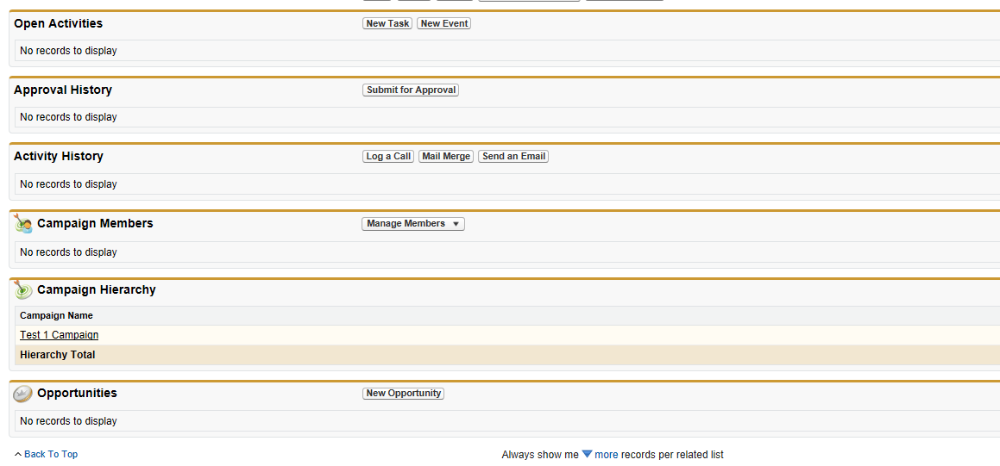

# Campaign Page Fields

In addition to displaying the Campaign Edit page fields, Salesforce displays these additional fields on the Campaign page:

|  |  |  |  |
| --- | --- | --- | --- |
| **Section** | **Field/Link** | **Description** | **Comment** |
| Campaign Statistics | Total Responses | Calculated field for the total number of contacts and unconverted leads that have a Member Status equivalent to “Responded” for the campaign.  Salesforce automatically calculates this amount using all associated records regardless of whether you have read access to them. | Read-only.  This field cannot be referenced in formulas for workflow rules, validation rules, field updates, or approval processes, but it can be referenced in custom formula fields. Updates to this field do not trigger workflow rules. |
|  | Total Leads | Number of potential opportunities (leads) associated with the campaign.  Salesforce automatically calculates this amount using all associated records regardless of whether you have read access to them. | This field cannot be referenced in formulas for workflow rules, validation rules, field updates, or approval processes, but it can be referenced in custom formula fields. Updates to this field do not trigger workflow rules. |
|  | Converted Leads | Number of leads that were converted to accounts due to the marketing efforts in the campaign.  Salesforce automatically calculates this amount using all associated records regardless of whether you have read access to them. | This field cannot be referenced in formulas for workflow rules, validation rules, field updates, or approval processes, but it can be referenced in custom formula fields. Updates to this field do not trigger workflow rules. |
|  | Total Contacts | Number of individuals on accounts that are associated with the campaign.  Salesforce automatically calculates this amount using all associated records regardless of whether you have read access to them. | This field cannot be referenced in formulas for workflow rules, validation rules, field updates, or approval processes, but it can be referenced in custom formula fields. Updates to this field do not trigger workflow rules. |
|  | Created By | User who created the campaign including creation date and time. | Read-only. |
|  | Num Total Opportunities | Calculated field for number of opportunities associated with the campaign.  Salesforce automatically calculates this amount using all associated records regardless of whether you have read access to them. | Read-only.  This field cannot be referenced in formulas for workflow rules, validation rules, field updates, or approval processes, but it can be referenced in custom formula fields. Updates to this field do not trigger workflow rules. |
|  | Num Won Opportunities | Calculated field for number of closed/won opportunities associated with the campaign.  Salesforce automatically calculates this amount using all associated records regardless of whether you have read access to them. | Read-only.  This field cannot be referenced in formulas for workflow rules, validation rules, field updates, or approval processes, but it can be referenced in custom formula fields. Updates to this field do not trigger workflow rules. |
|  | Total Value Opportunities | Calculated field for the amount of all opportunities associated with the campaign, including closed/won opportunities.  Salesforce automatically calculates this amount using all associated records regardless of whether you have read access to them. | Read-only.  This field cannot be referenced in formulas for workflow rules, validation rules, field updates, or approval processes, but it can be referenced in custom formula fields. Updates to this field do not trigger workflow rules. |
|  | Total Value Won Opportunities | Calculated field for amount of all closed/won opportunities associated with the campaign.  Salesforce automatically calculates this amount using all associated records regardless of whether you have read access to them. | Read-only.  This field cannot be referenced in formulas for workflow rules, validation rules, field updates, or approval processes, but it can be referenced in custom formula fields. Updates to this field do not trigger workflow rules. |
|  | Last Modified By | User who last changed the campaign fields, including modification date and time.  This does not track changes made to any of the related list items on the campaign. | Read-only. |

# Displaying a List of Campaigns

The Campaigns List page displays a list of campaigns in your current view. To show a filtered list of items, select a predefined list from the View drop-down list, or click Create New View to define your own custom views. To edit or delete any view you created, select it from the View drop-down list and click Edit.

1. Choose a campaign name to view the detail.
2. Click Edit or Del to edit or delete the campaign.

# Displaying the Details of a Campaign

Once you have located a campaign on the campaigns home or list pages, click the campaign name to display detailed information. You can also select a campaign name from the Campaign History related list of an associated lead, contact, or person account. If hover details are enabled, hover over any lookup field on the detail page to view key information about a record before clicking into that record’s detail page.

# Editing an Existing Campaign

Follow this procedure to edit an existing campaign:

1. When the page for an existing campaign is displayed, click the Edit button to update information about that campaign.

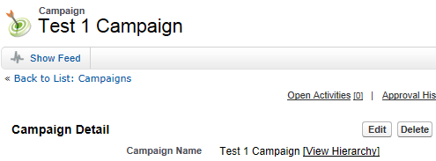

Result: Salesforce displays the Campaign Edit page that allows you to update and save campaign information.

1. Change the fields you want to update.
2. When you have finished, click Save. OR click Save & New to save the current campaign and create another.

Note: Use inline editing to edit fields directly on the detail page. If inline editing isn’t enabled, contact your administrator.

# Adding Campaign Members to a Campaign

You can add new members to a campaign:

* Individually from the Campaign History related list on a contact, lead, or person account detail page
* By searching for contacts and leads from the Manage Members page
* From a campaign, contact, person account, or lead report
* From a list view of existing contacts or leads
* From a CSV import file of new leads
* From a CSV import file of existing members

*Note: If a campaign has a campaign member type, you must have access to that campaign member type in order to add members to the campaign. Otherwise, you can only update existing campaign members.*

Your campaigns will target existing customers (contacts) and/or prospective customers (leads). You can associate both contacts and leads with your campaign as campaign members.

1. When the page for an existing campaign is displayed, click the Manage Members button.

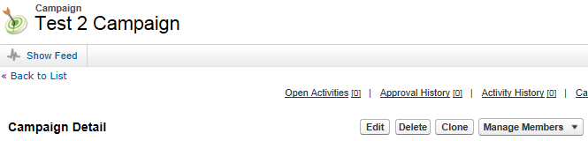

Result: Salesforce displays the Campaign Edit page that allows you to create the new campaign. The information you entered for the existing campaign is automatically populated so you only need to edit the appropriate information.

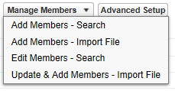

1. Select one of the following options:

**Add Members - Search** to [add campaign members](https://help.salesforce.com/HTViewHelpDoc?id=campaigns_members_using.htm&language=en_US) from a search.

**Add Members - Import File** to add campaign members by [importing leads](https://help.salesforce.com/HTViewHelpDoc?id=lead_import_wizard.htm&language=en_US) from a comma-delimited text file (.csv).

**Edit Members - Search** to [view, update, or delete](https://help.salesforce.com/HTViewHelpDoc?id=campaigns_members_editing.htm&language=en_US) existing campaign members.

**Update & Add Members - Import File** to [edit campaign member status](https://help.salesforce.com/HTViewHelpDoc?id=campaign_update_wizard.htm&language=en_US) using an import file.

1. Select the Add Members – Search option. *(This document does not cover the Import File available options.)*

Result: Salesforce displays the Add Members tab of the Manage Members page. In the example below, you are searching for contacts in the Elmwood PhillyRising area.

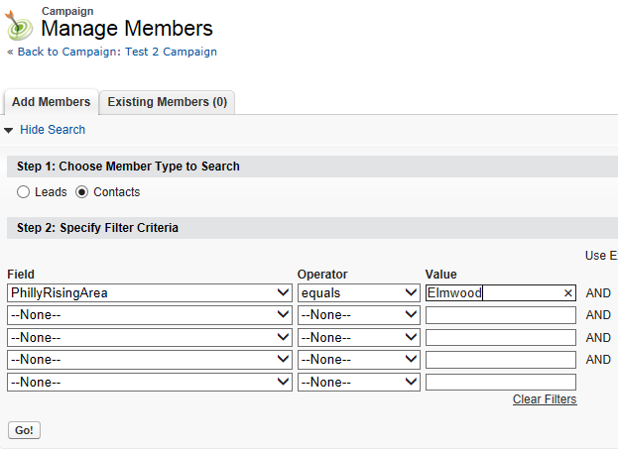

1. Click the Go! Button.

Result: In this example, Salesforce lists all of the contacts from the Elmwood PhillyRising area.

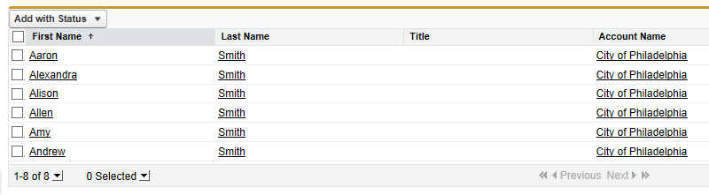

1. Select the contacts that you want to add to the campaign. To select all of the returned names, click the checkbox to the left of First Name.
2. Click the Add With Status button.
3. Choose the Sent option.

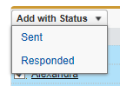

Result: Salesforce adds the contact to the Existing Members tab of the campaign.

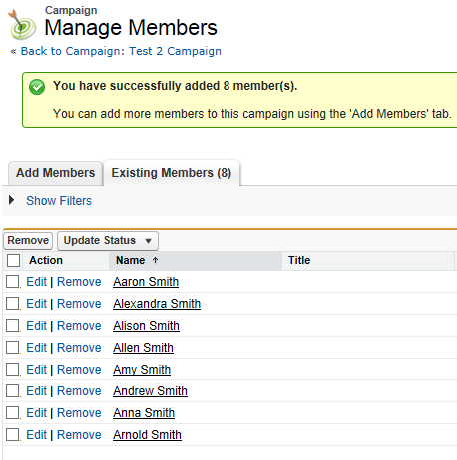

Salesforce also updates the number beside the Campaign Members link at the top of the page.



# Editing Campaign Members

You can edit the details of existing campaign members:

* Campaign History related list on a contact, lead, or person account detail page
* From the Campaign Members related list on a campaign detail page
* From the Manage Members page

# Updating the Status of Campaign Members

You can update the status of existing campaign members:

* [From the Campaign History related list](https://help.salesforce.com/apex/HTViewHelpDoc?id=campaigns_history.htm&language=en_US) on a contact, lead, or person account detail page
* [From the Manage Members page](https://help.salesforce.com/apex/HTViewHelpDoc?id=campaigns_members_editing.htm&language=en_US#topic-title)
* [From a campaign, contact, person account, or lead report](https://help.salesforce.com/apex/HTViewHelpDoc?id=campaigns_reportwizard.htm&language=en_US)
* [From a CSV import file of existing members](https://help.salesforce.com/apex/HTViewHelpDoc?id=campaign_update_wizard.htm&language=en_US)

# Removing Campaign Members

You can remove members of a campaign:

* From the Campaign History related list on a contact, lead, or person account detail page
* From the Campaign Members related list on a campaign detail page
* From the Manage Members page

# Creating Target Lists

The next step is to define who you want to target with the campaign – the campaign members. Some campaigns don't target individuals; for example, a banner posted on a third-party website is a campaign without members. If your campaign is targeting individuals, it is important to create a focused target list that has been segmented according to criteria that will yield the most high-quality prospects. To target existing contacts, you can use the Add to Campaign button on Salesforce reports and list views to add campaign members and specify their statuses.

To target existing leads or contacts:

1. Create a custom contact report.
2. In the “Select Criteria” step, enter up to three criteria to segment the report data.
3. Run the report.
4. Click Add to Campaign.

# Associating a Task to a Campaign

You can associate a task (activity) to a campaign.

Note: How to use the Assigned To field?

1. Create a new task.
2. On the New Task page, enter the information for the task.
3. In the Related To field, choose Campaign and then select the name of the associated campaign.

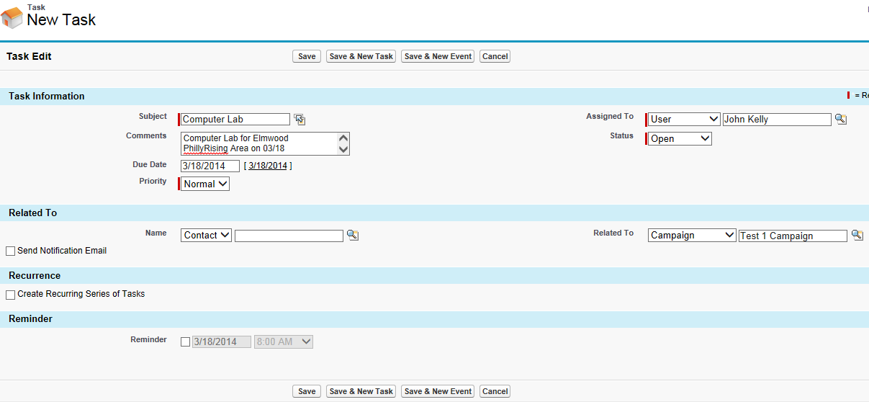

1. Return to the Campaign page for the associated campaign.

Result: Salesforce has added the task as an activity in the Open Activities related list:



Salesforce also updates the number beside the Open Activites link at the top of the page.



# Creating a Copy of a Campaign

Salesforce makes it easy for you to create a new campaign that is a copy of an existing campaign.

1. When the page for an existing campaign is displayed, click the Clone button.



Result: Salesforce displays the Campaign Edit page that allows you to create the new campaign. The information you entered for the existing campaign is automatically populated so you only need to edit the appropriate information.

1. Enter the name of the new campaign in the Campaign Name field.
2. Enter any other information specific to the new campaign.

# Printing Campaign Information

To view a printable display of all information for the campaign, click Printable View on the campaign detail page. Use the browser’s Print function to print the display.

# Sharing Campaigns

To share a campaign with other users, groups, or roles, click Sharing.

Your administrator defines your organization's sharing model for campaign access. However, you can extend sharing privileges for your own campaigns individually. Use campaign sharing to increase access to your campaigns; you cannot restrict access beyond your organization’s default access levels.

To view and manage sharing details:

1. Click **Sharing** on the Campaign Detail page.

Result: The Sharing Detail page lists the users, groups, roles, and territories that have sharing access to the campaign.

To show a filtered list of items:

1. Select a predefined list from the View drop-down list OR click **Create New View** to define your own custom views.

To edit or delete any view you created:

1. Select it from the View drop-down list and click **Edit**.
2. Click **Add** to grant access to the record for other users, groups, roles, or territories.
3. Click **Expand List** to view all users that have access to the record.

For manual sharing rules that you created:

1. Click **Edit** or **Del** next to an item in the list to edit or delete the access level.

Special Considerations

* To share a campaign, you must have Public Full Access to the campaign and have the Marketing User checkbox selected in your personal information.
* The **Sharing** button is available depending on your organization-wide default for campaigns.
* Make sure you are sharing records with users who have the appropriate “Read” object permission for viewing the shared records.
* Sharing a campaign does not automatically grant read access to all the campaign members. Make sure that the user you are sharing a campaign with has visibility to the associated leads or contacts.
* The campaign hierarchy statistic fields provide aggregate data for a parent campaign and all the campaigns below it in the hierarchy, regardless of whether a user has sharing rights to a particular campaign within the hierarchy. Therefore, consider your organization's campaign sharing settings when enabling campaign hierarchy statistics. If you do not want users to see aggregate hierarchy data, remove any or all of the campaign hierarchy statistic fields from the Campaign Hierarchy related list. These fields will still be available for reporting purposes.

# Deleting a Campaign

You should delete a campaign only if you created it in error. Otherwise your campaign reports would be incorrect. Generally, instead of deleting a campaign, you should change its status to Aborted.

If you do need to delete a campaign:

1. When the page for an existing campaign is displayed, click the Delete button.



Result: Salesforce displays a prompt.

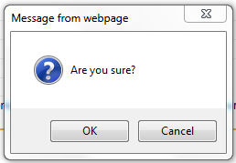

1. Click the OK button to confirm the deletion.

# Gathering Information at Neighborhood Events

Users will follow this procedure to gather information from community members at PhillyRising neighborhood events:

1. ???????????.

# Importing Information from Neighborhood Events

Users will follow this procedure to import information from PhillyRising neighborhood events into the Salesforce application:

1. ???????????.

# Calculating Campaign Statistics

The campaign detail includes campaign statistic fields, which are updated automatically and include values from all associated records regardless of whether you have read access to those records. If you have campaign hierarchies enabled, the Campaign Hierarchy related list contains aggregate statistics for a parent campaign and all the campaigns below it in the campaign hierarchy.

Campaign statistics on the campaign detail are automatically recalculated every time a campaign is saved. Some campaign statistics include Responses, Number of Opportunities, and Amount of Won Opportunities. Campaign hierarchy statistic fields, such as Total Responses in Hierarchy, Total Opportunities in Hierarchy, and Total Value Won Opportunities in Hierarchy, provide aggregate data for a parent campaign and all the campaigns below it in the campaign hierarchy.

*Note: The campaign statistics calculation process runs every two minutes and processes one campaign's statistics at a time. If there are a large number of campaigns or campaigns with large numbers of campaign members pending, there may be a delay of 10 minutes or more.*

# Campaign Reports

Use campaign reports to analyze your marketing efforts. You can report on the ROI of your campaigns, track who you targeted with your campaigns and who has responded, or analyze which opportunities resulted from your campaigns.

From the Reports tab, you can run several types of custom campaign reports as well as the following standard campaign reports:

* Use the **Campaign Leads** or **Campaign Contacts** reports to list the leads or the contacts associated with your campaigns.
* Use the **Campaign Call Down report** (single campaign) or the **Campaigns with Campaign Members report** (multiple campaigns) to show information about leads and contacts.
* Use the **Campaign Member Report** for a list of campaign members by campaign.
* Run the **Campaign Member Analysis report** to summarize information about who has responded to campaigns.
* Use the **Campaign Revenue Report** to analyze which opportunities have resulted from your campaigns. You can also analyze products and revenue schedules in this report.
* The **Campaign ROI Analysis Report** calculates the ROI and average costs for your campaigns. The ROI is calculated as the net gain (Total Value Opps - Actual Cost) divided by the Actual Cost. The ROI result is expressed as a percentage.
* Use the **Campaigns with Influenced Opportunities report** to view opportunities that are influenced by each of your campaigns.
* On the **Campaign Detail custom report** and the **Campaign ROI Analysis report**, you can include campaign-hierarchy statistics that provide aggregate values for a parent campaign and all the campaigns below it in the campaign hierarchy. If your campaigns include a custom picklist that indicates hierarchy level (for example, “tactic,” “program,” and “initiative”), you can run a report that summarizes data at any hierarchy level across all campaigns.

Tips for campaign reports:

* Some reports allow you to limit the data to one campaign by using the lookup icon to select a campaign. If the user running a report no longer has access to view the selected campaign, the report does not show any results. This report behavior is similar to what happens when a campaign is deleted.
* Member Status is the status of a lead or contact in reference to the campaign. The campaign owner can create up to 50 member status values. Sample Member Status values include, “Planned,” “Sent,” or “Attended.” Additionally, you can now add the Member First Associated, Responded, and Member First Responded fields to campaign reports. These fields allow you to see the date the member was added to the campaign, whether the member responded to the campaign, and the date the member initially responded to the campaign.
* The Last Activity of a campaign is the most recent due date of an activity on the record. The following past or future activities set this date: (1) Any event and (2) Closed tasks.

# Results Reporting

Different metrics for measuring the effectiveness of campaigns have been advanced by the city, primarily focusing around two subjects:

1. Crime Statistics
2. Quality-of-Life markers

To address these focus areas, Unisys will explore various methods accessible to the city to obtain data sets providing quantifiable measures of these metrics. Police statistics may be available from the Philadelphia Police Department or other reporting agencies, and could be loaded into Salesforce to track crime trends within the community’s targeted by the PhillyRising program, to compare the effectiveness in reducing crime and types of crime against the types of programs and responses to the programs offered to specific PhillyRising communities. ESRI/GIS functionality will be utilized to record Service Requests entered as Cases in the Salesforce environment, so that any change in the reporting or resolution of incidents can also be compared to the initiatives launched in the respective communities.

Metrics particular to the PhillyRising program will also be recorded and tracked back to specific outreach initiatives. These include attendance at events, as well as the community member’s attendance at and participation in follow-up events. Data will also be utilized to track the success the PhillyRising program is having in recruiting citizens to participate in the Neighborhood Liaison program.

Once Unisys has made these metrics available to the City through the Salesforce Campaign functionality, the city will be able to design and create custom reports and dashboards providing both historical and real-time information on the results of its efforts. These reports can be used to track both the cost effectiveness and net effectiveness of the different initiatives, and identify which Toolbox Processes are having the most impacts on the different communities.Ssss.

# Setting Up Campaign Hierarchies

Campaign hierarchies provide a powerful categorization tool that enables you to analyze and report on the health of your related campaigns. By associating campaigns with one another using a lookup relationship, you can group campaigns within a specific marketing program or initiative. A hierarchy can contain a maximum of five levels. Each campaign can have only one parent campaign but an unlimited number of sibling campaigns. By default, the Campaign Hierarchy related list appears on the campaign detail page but does not contain records until campaign hierarchies are configured for your organization.

To set up campaign hierarchies, add the Parent Campaign field to your campaign page layout and enable the campaign hierarchy statistics fields.

*Note: Depending on your user profile, the campaign hierarchy statistics fields may already be visible.*

* The campaign hierarchy fields include:
* Total Num Sent in Hierarchy
* Total Expected Revenue in Hierarchy
* Total Budgeted Cost in Hierarchy
* Total Actual Cost in Hierarchy
* Total Leads in Hierarchy
* Total Converted Leads in Hierarchy
* Total Contacts in Hierarchy
* Total Opportunities in Hierarchy
* Total Won Opportunities in Hierarchy
* Total Value Won Opportunities in Hierarchy
* Total Value Opportunities in Hierarchy
* Total Responses in Hierarchy

The process for making the fields visible depends on your Salesforce edition. For Enterprise, Unlimited, Performance, and Developer editions, use field-level security. As you make each field visible, Salesforce displays the field's value in the Hierarchy Total section of the Campaign Hierarchy related list. For Professional Edition, add the campaign hierarchy statistic fields to the campaign page layout; the fields will appear on the page layout and in the Hierarchy Total section of the Campaign Hierarchy related list.

The campaign hierarchy fields provide aggregate data for a parent campaign and all the campaigns below it in the campaign hierarchy, regardless of whether a user has sharing rights to a particular campaign within the campaign hierarchy. Therefore, consider your organization's campaign sharing settings when enabling campaign hierarchy fields. If you do not want users to see aggregate hierarchy data that includes campaigns to which the users do not have access, you can choose to remove any or all of the campaign hierarchy fields from the Campaign Hierarchy related list. If you do not add the campaign hierarchy fields to the related list or page layout, you can still access these fields on reports.

Once campaign hierarchies are set up, users can create and assign parent campaigns using Parent Campaign and then view details about the hierarchy on the Campaign Hierarchy page or the Campaign Hierarchy related list.

The Campaign Hierarchy page, accessible from the [view hierarchy] link next to the Campaign Name on the campaign record, shows all the levels in a hierarchy and the campaigns included in each level. The Campaign Hierarchy related list provides aggregate data for the parent campaign and all the campaigns below it in the hierarchy.

# Reviewing Campaign Hierarchies

A campaign hierarchy allows you to group campaigns together within a specific marketing program or initiative, which enables you to analyze related marketing efforts more efficiently.

To view the hierarchy for a campaign, click View Hierarchy next to the Campaign Name field on the campaign detail page. If a campaign is not part of a hierarchy, its corresponding Campaign Hierarchy page shows only the campaign you selected.

A campaign hierarchy shows campaigns that are associated with one another via the Parent Campaign field. A hierarchy illustrates a relationship between campaigns, such as a grouping of campaigns within a specific marketing tactic. Each campaign can have only one parent campaign but an unlimited number of sibling campaigns, and a campaign hierarchy can contain a maximum of five levels or generations. In other words, a campaign hierarchy has a maximum depth of five levels but an unlimited breadth on each level. Campaign members, such as contacts and leads, can be included on any level.

On the Campaign Hierarchy page, campaigns are indented to show that they are related to the campaigns above them. Campaigns are listed in descending order based on their hierarchy level. Click any campaign name to open the detail page for that campaign.

Statistics for an individual campaign are in the Campaign Statistics section of the campaign detail page. Aggregate statistics for parent and child campaigns are in the Campaign Hierarchy related list.

# Viewing Campaign Hierarchy Statistics

Campaign detail pages include a Campaign Hierarchy related list, which displays a parent campaign and all the campaigns directly below the parent campaign in the campaign hierarchy. You can create a campaign hierarchy by associating campaigns with one another using the Parent Campaign lookup field on the campaign detail page. Click any campaign in the related list to open the detail page for that campaign.

The Campaign Hierarchy related list provides statistics fields for each campaign in the list as well as the total value for the parent campaign and all the campaigns below it in the campaign hierarchy. Statistics fields are not visible in the related list until campaign hierarchies are enabled for your organization. For more information and a list of fields, see Setting Up Campaign Hierarchies.

The Campaign Hierarchy related list shows a maximum of two hierarchy levels: the parent campaign and its child campaigns. If a child campaign has children, those children do not appear in the related list but their data is included in the campaign hierarchy statistic field values. The campaign hierarchy statistic fields provide aggregate data regardless of whether you have sharing rights to view individual campaigns within the hierarchy. However, if you do not have access to a campaign that appears in the related list, you cannot view its detail page from the link on the related list. To view all the levels in a campaign hierarchy, click the View Hierarchy link next to the Campaign Name on the campaign detail page.

# Configuring Campaign Hierarchies for PhillyRising

The campaign hierarchies will be set up for PhillyRising communities as follows:

* South Division
  + Point Breeze
  + Southeast
* Central Division
  + Market East
  + Strawberry Mansion
  + Penrose
  + North Central
* Northwest Division
  + Swampoodle
* Southwest Division
  + Elmwood
  + Haddington
  + Kingsessing
  + St. Hugh’s
* Northeast Division
  + Frankfort
  + Lawncrest
* Philly 2.0
  + TBD

# Configuring Campaign Fields

The following describes the standard Salesforce fields and custom fields created for the City:

| **Field Label** | **Field Type** | **Custom** | **R e q u**  **I**  **r**  **e**  **d** | **R e a d**  **O n l y** | **Validation**  **Rule #** | **H i s t o r y** | **Comments** |
| --- | --- | --- | --- | --- | --- | --- | --- |
| Toolbox Process | Picklist  **Values:** Citizen Engagement Academy, Large-Scale Volunteer Event, MAP Mural, Alleyway Cleaning Campaign, Domestic Violence Workshop, Neighborhood Liaison Training, Career Boot Camp, Computer Lab, Quality of Life Survey, Community Leader Social, Gardening Project, Health Fair / Outreach, Dream Drive  **Default:** | Y | Y | N |  | N | These are the specific activities that the city is using to promote citizen engagement in the targeted areas. |
| Campaign Type | Picklist  **Values:** Door-to-Door, Door Hangers, Mass Email, Mass Advertising, Targeted Email, Website  **Default:** |  |  |  |  |  | How the campaign reached out to the citizens of the community. |
| Lead Status | Picklist  **Values:** Contacted, Contacted / No Response, Registered, Registered – Attended, Registered – No show  **Default:** |  |  |  |  |  | Record any responses of a lead to a campaign activity. |
| PhillyRising Community | Picklist  **Values:** Elmwood, Frankford, Haddington, Hartranft, Kensington, Kingsessing, Lawncrest, Market East, North Central, Penrose, Pt. Breeze, St. Hugh, Southeast, Strawberry Mansion, Swampoodle  **Default:** |  |  |  |  |  | This will track the PhillyRising community being targeted. |
|  |  |  |  |  |  |  |  |

# Configuring Related Lists

Hover over the links at the top of a detail page to display the corresponding related list and its records. If Chatter is enabled, hover links display below the feed. An interactive overlay allows you to quickly view and manage the related list items. Click a hover link to jump to the content of the related list. If hover links are not enabled, contact your Salesforce administrator.

The lower portion of the display provides information related to the campaign including activities, attachments, campaign members, campaign hierarchies, and the opportunities that resulted from the campaign. The related lists you see are determined by your personal customization, and by any customization your administrator has made to page layouts or your permissions to view related data. You can click individual items to display additional detail. Click More at the bottom of the page or View More below a related list to display more items.

The following table describes the “standard” related liststhat PhillyRising will use.

| **Related List** | **Description** |
| --- | --- |
| Open Activities | This related list displays open tasks and open event (appointment, call, email, meeting, etc.) that have been associated to the campaign. A calendar can also be displayed showing scheduled events. Is this true? Test this. |
| Approval History | This related list displays ?????. |
| Activity History | This related list displays all completed tasks, logged phone calls, saved interaction logs, expired events, outbound emails, and merged documents that have been associated to the campaign. Is this true? Test this. |
| Campaign Members | This related list displays all the campaign members associated with the campaign. |
| Campaign Hierarchy | When a campaign is being created or edited it can be designated as a “child campaign” by setting a “parent campaign” using the Parent Campaign field. This related list displays all of the child campaigns for a parent campaign. |
| Opportunities | This related list displays ????? |

# Configuring Assigned Apps

These are the default configuration settings for assigned apps.

| **App Name** | **Field** | **Value** | **Comment** |
| --- | --- | --- | --- |
| Assigned Apps | App Name | Marketing |  |
|  | Visible | Checked |  |
|  | Default | Not Checked |  |

# Configuring Campaign Picklists

From Setup, click Customize > Campaigns > Fields. These are the default configuration settings for campaign picklists.

| **Picklist** | **Value** | **Comment** |
| --- | --- | --- |
|  |  |  |
|  |  |  |
|  |  |  |

# Configuring Custom Fields

From Setup, click Customize > Campaigns > Fields. These are the default configuration settings for campaign custom fields.

| **Custom Field** | **Value** | **Comment** |
| --- | --- | --- |
|  |  |  |
|  |  |  |
|  |  |  |

# Configuring Permission Sets

From Setup, click Manage Users > Profiles or Manage Users > Permission Sets. These are the default configuration settings for user permission sets.

| **Permission Set** | **Value** | **Comment** |
| --- | --- | --- |
|  |  |  |
|  |  |  |
|  |  |  |

*Note: To use campaign hierarchy fields, you must enable them using field-level security.*

# Configuring Campaigns

These are the default configuration settings for campaigns.

| **Section** | **Field** | **Value** | **Comment** |
| --- | --- | --- | --- |
| Tab Settings |  | Default On |  |
| Record Types and Page Layout Assignment | Record Type | --Master-- |  |
|  | Page Layout Assignment | Campaign Layout |  |
|  | Assigned Record Types | Checked |  |
|  | Default Record type | Checked |  |
| Object Permissions | Read | Enabled |  |
|  | Create | Enabled |  |
|  | Edit | Enabled |  |
|  | Delete | Enabled |  |
|  | View All | Enabled |  |
|  | Modify All | Enabled |  |
| Field Permissions | Active |  |  |
|  | Actual Cost |  |  |
|  | Budgeted Cost |  |  |
|  | Campaign Member Type |  |  |
|  | Campaign Name |  |  |
|  | Campaign Owner |  |  |
|  | Converted Leads |  |  |
|  | Created By |  |  |
|  | Description |  |  |
|  | End Date |  |  |
|  | Expected Response (%) |  |  |
|  | Expected Revenue |  |  |
|  | Last Modified By |  |  |
|  | Num Sent |  |  |
|  | Num Total Opportunities |  |  |
|  | Num Won Opportunities |  |  |
|  | Parent Campaign |  |  |
|  | PhillyRising Community |  |  |
|  | Start Date |  |  |
|  | Status |  |  |
|  | Toolbox Process |  |  |
|  | Total Actual Cost in Hierarchy |  |  |
|  | Total Budgeted Cost in Hierarchy |  |  |
|  | Total Contacts |  |  |
|  | Total Contacts in Hierarchy |  |  |
|  | Total Converted Leads in Hierarchy |  |  |
|  | Total Expected Revenue in Hierarchy |  |  |
|  | Total Leads |  |  |
|  | Total Leads in Hierarchy |  |  |
|  | Total Num Sent in Hierarchy |  |  |
|  | Total Opportunities in Hierarchy |  |  |
|  | Total Responses |  |  |
|  | Total Responses in Hierarchy |  |  |
|  | Total Value Opportunities |  |  |
|  | Total Value Opportunities in Hierarchy |  |  |
|  | Total Value Won Opportunities |  |  |
|  | Total Value Won Opportunities in Hierarchy |  |  |
|  | Total Won Opportunities in Hierarchy |  |  |
|  | Type |  |  |

# Configuring Campaign Members

These are the default configuration settings for campaign members.

|  |  |  |  |
| --- | --- | --- | --- |
| **Section** | **Field** | **Value** | **Comment** |
| Record Types and Page Layout Assignment | Record Type | --Master-- |  |
|  | Page Layout Assignment | Campaign Member Page Layout |  |
|  | Assigned Record Types | Checked |  |
|  | Default Record type | Checked |  |
| Field Permissions | Campaign |  |  |
|  | City |  |  |
|  | Company (Account) |  |  |
|  | Contact |  |  |
|  | Country |  |  |
|  | Created By |  |  |
|  | Created Date |  |  |
|  | Description |  |  |
|  | Do Not Call |  |  |
|  | Email |  |  |
|  | Email Opt Out |  |  |
|  | Fax |  |  |
|  | Fax Opt Out |  |  |
|  | First Name |  |  |
|  | First Responded Date |  |  |
|  | Last Modified By |  |  |
|  | Last Modified Date |  |  |
|  | Last Name |  |  |
|  | Lead |  |  |
|  | Lead Source |  |  |
|  | Mobile |  |  |
|  | Phone |  |  |
|  | Responded |  |  |
|  | Salutation |  |  |
|  | State/Province |  |  |
|  | Status |  |  |
|  | Street |  |  |
|  | Title |  |  |
|  | Zip/Postal Code |  |  |

# Configuring Campaign Page Layouts

Modify campaign page layouts to organize the fields and related lists on the page and control which fields users see on detail and edit pages. To modify campaign page layouts:

1. From Setup, click Customize.
2. Select the Campaigns link.
3. Click the Page Layouts link.
4. Modify the page layout as needed.

Add the “Member First Associated” and “Member First Responded” fields to the Campaign History related list. These fields allow you to see the date that a member was added to the campaign and the date a member initially responded to the campaign.

# Configuring Campaign Page Layouts

Modify which campaign page layouts apply to users with the Marketing User profile. You can also modify other profiles to restrict campaign access. From Setup, click Manage Users > Profiles.

1. Click the name of an existing profile to modify it, or click New Profile.
2. For each profile, select a campaigns page layout to determine how the campaign pages will display for users with that profile.
3. For each custom profile, determine whether to show or hide the Campaigns tab. The tab settings for the standard profiles cannot be changed.
4. For each custom profile, select which permissions to enable. The permission settings for the standard profiles cannot be changed.

# Configuring Campaign List Views

Create customized list views to provide quick access to campaigns based on specific criteria. For example, you might create a list view to show all direct mail campaigns. You might also modify the standard list views to include some of your custom fields. To customize campaign list views:

1. Navigate to the Campaigns tab.
2. To show a filtered list of items, select a predefined list from the View drop-down list, or click Create New View to define your own custom views. To edit or delete any view you created, select it from the View drop-down list and click Edit.
3. Give the list view a name.
4. Select All campaigns or My campaigns to restrict the list to campaigns owned by the user viewing the list.
5. Set the criteria for the list view. For example, set Type equals Direct Mail to create a list view of all direct mail campaigns.
6. Select the fields to display in the list view. You can choose any standard or custom campaign fields.
7. Set the visibility to Visible to all users to make the list view public.
8. Click Save to finish.

# Configuring Campaign Goals

If you want to analyze your marketing budget by campaign goal, add a custom campaign picklist called Campaign Goal to track the primary goal of each campaign. This picklist should include values such as Brand building, Lead generation, and any other campaign goals your organization might have.

Question: Include Campaign Sharing?

Question: Include Campaign Opportunities?